INDEX

| Chapter No. | Title | Page No. |
| --- | --- | --- |
| 1 | Introduction  1.1. Introduction to the project  1.2. Motivation for the project  1.3. Drawback of the existing system  1.4. Problem Definition  1.5 Relevance of the Project  1.6 Methodology used | 3 |
| 2. | Literature Survey  2.1. Research Papers  a. Abstract of the research paper  b. Inference drawn from the paper  2.2. Books / Articles referred / news paper referred | 6 |
| 3. | Requirement Of Proposed System  3.1 Functional Requirements  3.2. Non-Functional Requirements  3.3. Constraints  3.4. Hardware & Software Requirements  3.5. Techniques utilized till date for the proposed system  3.6. Tools utilized till date for the proposed system  3.7. Algorithms Utilized in Existing Systems | 12 |
| 4. | Proposed Design  4.1 Block diagram representation of the proposed system  4.2. Modular diagram representation of the proposed system  4.3 Design of the proposed system: Dataflow, Flowchart, State transition, Screenshot  4.4 Results | 13 |
| 5. | Proposed Results and Discussions  5.1 Proposed Output  5.2 Evaluation Parameters  5.3 Reports on sensitivity analysis | 24 |
| 6. | Plan Of Action For the Next Semester  6.1 Work done to date  6.2 Plan of action for project II | 25 |
| 7. | Conclusion | 26 |
| 8. | References | 27 |
| 9. | Appendix  9.1 List Of Figures  9.2 List Of Tables  9.3 List Of Abbreviations  9.4 Paper Publications   1. Draft of the paper / Paper Published 2. Plagiarism report of the paper 3. Xerox of project review sheet (1 per student ) | 29 |

**Chapter 1: Introduction**

#### 1.1 Introduction to the Project

#### The state-of-the-art AI-powered Well Mind Chatbot is intended to offer quick and convenient mental health support. It provides a private, secure setting where individuals can talk about their thoughts, feelings, and experiences with mental health. For anyone in need of mental health assistance, especially those who might find it challenging to access conventional therapy or counseling services, the Well Mind Chatbot is a useful resource. It seeks to enhance mental health and encourage a better, happier life by fusing cutting-edge technology with compassionate treatment.

#### 1.2 Motivation for the Project

The need for readily available, reasonably priced mental health care, particularly in places where traditional therapy and counseling facilities may be scarce or nonexistent, motivated the creation of the Well Mind Chatbot. The following are the main driving forces behind the project:Handling the Mental Health Crisis: The rising incidence of mental health conditions like stress, anxiety, and depression has brought attention to the critical need for creative approaches to help those in need.Breaking Down Barriers: Due to stigma, expense, or a lack of knowledge, many people find it difficult to seek professional assistance. The Well Mind Chatbot seeks to remove these obstacles by giving people a private, easy-to-use platform to get help.

#### 1.3 Drawbacks of the Existing System

Even if the Well Mind Chatbot has many advantages, there are certain built-in drawbacks to take into account:

**Absence of Human Connection**: Although the chatbot can offer information and emotional support, it is unable to completely replace the empathy and human connection that a therapist or counselor can provide.

**Limited Understanding**: Despite being programmed to comprehend and reply to user inquiries, the chatbot might not always be able to pick up on the subtleties of intricate circumstances or feelings.

**Dependency**: Relying too heavily on the chatbot as their only source of assistance may prevent people from getting help from a professional when they need it.

**Privacy Concerns:** Although the chatbot is made to safeguard user privacy, there is always a chance that unwanted access or data breaches will occur.

#### 1.4 Problem Definition

The following are the main issues in the field of mental health that Well Mind Chatbot seeks to address: Restricted Accessibility: A lot of people have trouble getting competent mental health services because of their location, the expense, or their ignorance. Discrimination and Stigma: Even in cases of severe distress, people may be discouraged from seeking assistance due to the stigma attached to mental health. Inadequate or Delayed Support: People may need emergency assistance during times of crisis, which can be challenging to get through conventional channels. Absence of Personalized Care**:** The special needs and experiences of each user may not be met by generic mental health resources. Through easily available, private, and tailored assistance, Well Mind Chatbot aims to: Boost accessibility: Provide mental health services to a larger group of people, irrespective of their geography or socioeconomic standing. Diminish stigma: Encourage people to seek treatment without feeling judged and to have honest discussions about mental health. Give prompt support: Assist those going through mental health problems right away. Provide individualized service by adjusting responses and suggestions to each user's unique requirements and preferences.

#### 1.5 Relevance of the Project

Given the rising incidence of mental health problems and the shortcomings of conventional mental health treatment, Well Mind Chatbot is extremely pertinent in today's society. The following elements contribute to its relevance:Growing Mental Health Concerns: Anxiety, depression, and other mental health concerns are on the rise as a result of the COVID-19 pandemic's exacerbation of mental health issues. Accessibility Gaps: Availability, price, and accessibility of traditional mental health services are frequently restricted, especially in rural or underprivileged locations.Discrimination and Stigma: Even in cases of severe distress, people may be discouraged from seeking assistance due to the stigma attached to mental health.

#### 

#### 1.6 Methodology Used

Approaches Applied in the Well Mind Chatbot

The following approaches are probably used in combination by Well Mind Chatbot to deliver its mental health support:

1. Natural Language Processing (NLP): Text Analysis: To comprehend intent, sentiment, and keywords, NLP algorithms examine user-provided text.

Language Generation: Using the user's input, the chatbot produces responses that are logical, pertinent, and sympathetic.

2. Machine Learning: Supervised Learning: To identify patterns and relationships, a dataset of exchanges and responses may be used to train the chatbot.

Reinforcement Learning: Over time, the chatbot's efficacy can be enhanced by adapting its responses based on user interactions.

3. Knowledge Base: Information Retrieval: The chatbot has access to a knowledge base containing resources, coping mechanisms, and information on mental health-related subjects.

4. Sentiment Analysis: Emotion Detection: The chatbot can identify the underlying emotions expressed in the user's text, such as sadness, anger, or anxiety. Empathetic Responses: Based on the detected emotions, the chatbot can generate responses that are empathetic and supportive.

5. User Interface Design: Intuitive Interface: The chatbot's interface should be user-friendly and easy to navigate. Privacy and Security: The chatbot should prioritize user privacy and data security.

6. Ethical Considerations: Bias Mitigation: The chatbot should be designed to avoid biases and ensure that responses are fair and unbiased. Professional Guidance: While the chatbot can provide support, it should also encourage users to seek professional help when necessary.

**Chapter 2: Literature Survey**

The literature survey provides an in-depth review of existing research, books, articles, and expert interactions relevant to the project. It highlights the knowledge gaps that *wellmind chatbot* seeks to address while supporting the project's methodology and problem definition.

#### 2.1 Research Papers

Table I. Literature Survey

| **Paper** | **Abstract summary** | **Limitations** |
| --- | --- | --- |
| **Author:** M. A. Salehinejad et al.  **Year & Publication:**  IEEE Journal of Biomedical and Health Informatics, vol. 24, no. 8, pp. 2313-2325, August 2020  **Title:** "Recent Advances in Using AI for Mental Health and Well-Being," | **AI Applications in Mental Health**: The paper explores how AI, through techniques like machine learning and natural language processing, is being increasingly used to improve mental health care, offering better diagnosis, treatment, and personalized support.  **Data-Driven Insights**: AI's capability to analyze vast amounts of data, including social media content and brain imaging, allows for early detection and more accurate predictions of mental health issues. | **Data Privacy and Bias**: Handling sensitive mental health data raises significant privacy concerns, and AI models risk perpetuating biases present in training data, potentially leading to unequal care.  **Lack of Clinical Validation**: Many AI tools for mental health are not yet clinically validated, requiring more real-world testing to ensure their reliability and effectiveness. |
| **Author:** J. Torous, M. D. Myrick, C. Rauseo-Ricupero  **Year & Publication:** JMIR Mental Health, vol. 7, no. 3, 2020.  **Title:** "Digital Mental Health and COVID-19: Using Technology Today to Accelerate the Curve on Access and Quality Tomorrow," | **Digital Tools in COVID-19**: This paper examines the role of digital mental health technologies during the COVID-19 pandemic, emphasizing their potential to expand access to mental health services.  **Quality and Integration**: While digital tools can help meet increased demand, concerns remain about their quality and integration with existing healthcare systems.  **Digital Divide**: The effectiveness of these tools is limited by unequal access to technology among different populations. | **Digital Divide**: The effectiveness of digital mental health tools is limited by unequal access to technology, particularly among underserved populations.  **Quality Concerns**: The rapid deployment of digital tools during the pandemic raises concerns about the quality and efficacy of these interventions.  **Integration Challenges**: There are challenges in seamlessly integrating digital tools with traditional healthcare systems to ensure continuity of care. |
| **Author:** A. L. Christensen  **Year & Publication:** 2021  **Title:**  "Efficacy of Mental Health Chatbots in Providing Psychological Support: A Systematic Review," | 1. The paper discusses various elements of sleep, including tiredness, sleep quality, duration, efficacy, and latency.  2. Blue light exposure can negatively affect sleep quality by potentially decreasing sleep duration and increasing sleep latency, as some studies indicate. | **Limited Efficacy**: The review finds that chatbots are generally less effective than human therapists, particularly for complex mental health conditions.  **Lack of Personalization**: Many chatbots struggle to offer personalized support, limiting their effectiveness in addressing individual needs. |
| **Author:**K. Inkster, et al.  **Year & Publication:**  Frontiers in Psychiatry, 2020.  **Title:** , "Machine Learning and Mental Health: Applications, Challenges, and Ethical Concerns," | **Machine Learning in Mental Health**: This paper discusses the applications of machine learning (ML) in mental health, including diagnosis and treatment recommendations.  **Bias and Privacy Issues**: ML models may inherit biases from training data and pose privacy risks when handling sensitive health information. | **Bias and Fairness**: Machine learning models may perpetuate biases present in the training data, leading to unequal outcomes for different populations.  **Data Privacy**: The use of sensitive mental health data in ML models raises significant privacy concerns, requiring robust safeguards. |
| **Author:** J. Abdullah,  **Year & Publication:**  Ethics & Information Technology, 2021..  **Title:** , "Chatbots as Digital Mental Health Interventions: Examining the Ethical Implications," | **Ethics of Chatbots**: Abdullah's paper focuses on the ethical implications of using chatbots in mental health care, such as user autonomy and the potential for harm.  **Informed Consent**: Users may not fully understand the limitations of chatbots, leading to issues with informed consent. | **Autonomy and Informed Consent**: Users may not fully understand the limitations of chatbots, potentially leading to overreliance and uninformed consent.  **Potential for Harm**: There is a risk that chatbots may provide inadequate or inappropriate responses, which could worsen the user's condition. |
| **Author:**B. Kumar  **Year & Publication:** ACM Transactions on Health Informatics, 2020.  **Title:** ,"Natural Language Processing in AI-Powered Mental Health Tools," | **Language and Cultural Barriers**: NLP models may struggle with language nuances and cultural differences, potentially leading to misunderstandings in communication.  **Data Quality**: The effectiveness of NLP depends on the quality and diversity of the data used for training, which can be a limiting factor.. | **NLP in Mental Health**: The paper explores how natural language processing (NLP) is used in AI-powered mental health tools to improve user interaction.  **Language and Cultural Barriers**: NLP models may struggle with language nuances and cultural differences, affecting communication. |
| **Author:** Higgins et al.,  **Year & Publication:**  Ethics & Information Technology, 2021..  **Title:** , "AI and ML-Based Decision Support Systems in Mental Health: An Integrative Review | **AI in Decision Support**: The paper reviews the use of AI and ML in decision support systems for mental health, highlighting their potential to improve diagnostic accuracy.  **Validation and Ethics**: Many AI systems lack clinical validation, and their use raises ethical concerns regarding transparency. | **Clinical Validation**: Many AI and ML-based systems lack robust clinical validation, making their real-world efficacy uncertain.  **Ethical Concerns**: The use of AI in decision-making raises ethical issues, particularly regarding the transparency and accountability of these systems. |
| **Author:** Minerva & Giubilini  **Year & Publication:**  *Topoi* 42.3 (2023)  **Title:** ,"Is AI the Future of Mental Healthcare?" | **AI in Mental Healthcare**: This paper discusses the potential of AI to revolutionize mental healthcare, offering more accessible and efficient services.  **Ethical Dilemmas**: The potential replacement of human therapists with AI raises significant ethical concerns. | **Ethical Dilemmas**: The potential replacement of human therapists with AI raises significant ethical concerns.  **Human-AI Interaction**: The effectiveness of AI in mental healthcare depends heavily on how well it can replicate the nuances of human interaction, which remains a challenge. |
| **Author:** Tutun et al.  **Year & Publication:**  *Information Systems Frontiers* 25.3 (2023)  **Title:** , "An AI-Based Decision Support System for Predicting Mental Health Disorders | **AI Predictive Systems**: The paper presents an AI-based system designed to predict mental health disorders using machine learning algorithms.  **Prediction Accuracy**: The accuracy of AI predictions is a concern, as errors can lead to incorrect diagnoses. | **Prediction Accuracy**: The accuracy of predictions made by AI systems is not always reliable, which can lead to false positives or negatives.  **Data Dependency**: The system's performance is highly dependent on the quality and comprehensiveness of the data used for training. |
| **Author:**Hamdoun et al.  **Year & Publication:** ACM Transactions on Health Informatics, 2020.  **Title:** ,"*IEEE Technology and Society Magazine* 42.1 (2023)" | **AI Mental Health Apps**: This paper examines AI-based mental health apps, balancing the need for these tools with the risks they pose.  **Privacy and Security**: The use of personal data in these apps raises significant privacy and security concerns. | **Risk of Misuse**: The accessibility of AI-based mental health apps increases the risk of misuse, especially without proper guidance from professionals.  **Privacy and Security**: The use of personal data in these apps raises significant privacy and security concerns, particularly regarding data breaches. |

### 

### Chapter 3: Requirements for the Proposed System

The requirements for *Wellmind Chatbot* comprise functional, non-functional, and technical specifications to ensure the system’s success in addressing climate impacts on agriculture.

#### 3.1 Functional Requirements

Essential Roles:Understanding and interpreting user input, such as text and voice messages, is known as natural language understanding (NLU).Produce responses to user statements and inquiries that are human-like using natural language generation (NLG).Information Retrieval: Access and obtain pertinent data from a knowledge base containing resources, coping mechanisms, and issues related to mental health.Sentiment analysis: Recognize the user's feelings, such as grief, rage, or anxiety, and react accordingly.Personalized Recommendations: Make recommendations that are specifically catered to the requirements and preferences of the user.Crisis Intervention: Recognize and assist users who are experiencing a crisis by offering them quick help and direction.Integration Capabilities: Integration with Other Platforms: Integrate with popular messaging platforms (e.g., WhatsApp, Facebook Messenger) to expand accessibility. Integration with Healthcare Providers: Connect with healthcare providers to share relevant information and facilitate referrals. Integration with Wearable Devices: Integrate with wearable devices to track user's physical and emotional well-being. These functional requirements ensure that Well Mind Chatbot can provide a comprehensive and effective mental health support tool that meets the needs of a diverse user base.

#### 3.2 Non-Functional Requirements

Non-Functional Requirements for Well Mind Chatbot Non-functional requirements (NFRs) are quality attributes that define how a system should operate. Here are some key NFRs for Well Mind Chatbot: Reliability: High Availability: The chatbot should be available 24/7 to ensure continuous support. Fault Tolerance: The system should be able to recover from errors or failures without significant disruption. Data Integrity: User data should be protected from loss or corruption. Performance: Response Time: The chatbot should respond to user queries promptly, ideally within a few seconds. Scalability: The system should be able to handle increasing user loads without compromising performance. Security: Data Privacy: User data should be protected from unauthorized access, disclosure, alteration, or destruction. Data Confidentiality: Sensitive information should be kept strictly confidential.Usability: User-Friendliness: The chatbot's interface should be straightforward and easy to use, especially for those with low technological skills.Accessibility: People with disabilities, such as those who have visual or hearing difficulties, should be able to utilize the chatbot.Language Support: In order to reach a larger audience, the chatbot should support several languages.Modularity: To enable updates, alterations, and maintenance, the chatbot's design should be modular.Documentation: To assist with development, maintenance, and troubleshooting, clear and thorough documentation should be supplied.Platform Independence: To guarantee broad accessibility, the chatbot should be able to function across a variety of platforms, such as the web and mobile.Through the resolution of these non-functional needs, Well Mind Chatbot can guarantee its users a dependable, aesthetically pleasing experience.

#### 3.3 Constraints

#### Constraints of the Well Mind Chatbot:

#### Technologically, the chatbot may not be as effective or as powerful as it could be due to a number of limitations. These include natural language understanding limitations that could result in inaccurate or irrelevant responses. Emotional intelligence limitations could mean that although the chatbot can identify and react to basic emotions, it may not fully comprehend or empathize with complex emotional states. Data limitations could mean that the chatbot's capacity to learn and grow is reliant on the caliber and volume of the data it is trained on. Finally, there are the ethical constraints of bias and discrimination.

Regulatory and Legal Restraints:Requirements for Compliance: The chatbot needs to abide by all applicable laws and rules, including those pertaining to data protection and healthcare.Liability Concerns: Should the chatbot deliver dangerous or erroneous information, its developers may be held legally liable.These limitations draw attention to the difficulties that Well Mind Chatbot faces in order to deliver morally and practically sound mental health assistance. It will take continued research, development, and ethical considerations to address these limitations

#### 3.4 Hardware & Software Requirements

Processor: It is advised to use a multi-core processor with at least 4 cores (or more for increased performance).RAM: It is recommended to have at least 8GB of RAM, although managing complicated jobs and big datasets may benefit from having 16GB or more.Storage: For better speed and quicker data access, a solid-state drive (SSD) is recommended.Network Connectivity: Accessing data and interacting with users require a dependable internet connection.Operating System: The operating system can be Linux, Windows, or macOS.Programming Language: Because of its many libraries and frameworks, Python is a popular choice for creating chatbots.NLP Resource Collections: Understanding and processing user input requires the use of Natural Language Processing libraries like Gensim, spaCy, and NLTK.Machine Learning Frameworks: To create and train machine learning models, you'll need frameworks like PyTorch or TensorFlow.Database: To store user data, chatbot responses, and other pertinent information, a database system (such as MySQL or PostgreSQL) is required.Cloud Platform (Optional): To grow the chatbot's infrastructure and increase dependability, a cloud platform like AWS, GCP, or Azure can be utilized.Integration with Messaging Platforms: Libraries or APIs for combining with well-known messaging services (such Facebook Messenger, WhatsApp, etc.)

#### 3.5 Techniques Utilized

#### Methods the Well Mind Chatbot Uses

It's possible that Well Mind Chatbot uses a mix of the following strategies:Tokenization is the process of dissecting text into discrete words or tokens using natural language processing (NLP).Lemmatization and stemming: reducing words to their most basic form to enhance comprehension.A portion of speech tagging is the process of determining each word's function in a sentence's grammar.Named Entity Recognition: The process of recognizing names for things like persons, locations, and organizations. Sentiment analysis: Identifying the text's emotional undertone.Machine Learning: Supervised Learning: Using labeled datasets, train the chatbot to recognize patterns and generate predictions.Unsupervised learning is the process of identifying hidden patterns and relationships by analyzing unlabeled data.Reinforcement learning involves learning by making mistakes and rewarding the chatbot for right answers while penalizing it for wrong ones.Artificial neural networks are used in deep learning to simulate intricate interactions between inputs and outputs.Recurrent Neural Networks (RNNs): Recognizing context and preserving state through processing sequential data, like talks.RNNs with long short-term memory (LSTM) are able to retain information for extended periods of time.Information can be represented semantically by using a knowledge graph, which is a graph of related things and relationships.Information Retrieval: Based on user queries, relevant information is retrieved using the knowledge network.Management of Dialogue:State Tracking: Maintaining an archive of past conversations as well as the chatbot's present state.Dialog Act Classification: Determining the speaker's intention.Response Generation: Producing pertinent answers in accordance with the user's intention and the chatbot's current status.

#### 3.6 Tools Utilized

#### Instruments Used in the Well Mind Chatbot

#### It's possible that Well Mind Chatbot makes use of a mix of the following frameworks and tools.

#### Languages Used in Programming:

#### Python: Because of its many libraries and frameworks, this language is well-liked for projects involving AI and machine learning.

#### NLTK: A well-known Python library for tasks involving natural language processing.

#### spaCy: Another well-liked NLP library that is renowned for its effectiveness and quickness.

#### Gensim: A library for document similarity and topic modeling.

#### Frameworks for Machine Learning:

#### TensorFlow: A well-known machine learning open-source platform created by Google.

#### Another well-liked deep learning framework is PyTorch, which is renowned for being user-friendly and flexible.

#### Deep Learning Structures:

#### Keras: A high-level API that makes developing deep learning models easier and can be used with TensorFlow or Theano.

#### Frameworks for Dialog Management:

#### Rasa is a free and open-source platform for creating AI chatbots.

#### Dialogflow is a conversational interface building tool available on Google Cloud.

#### Platforms for the Cloud:

#### Amazon Web Services, or AWS, is a well-known cloud computing platform that provides a variety of services for hosting and growing applications.

#### Another well-known cloud platform with a heavy emphasis on AI and machine learning is GCP (Google Cloud Platform).

#### Azure: A range of services for developing and implementing apps are provided by Microsoft's cloud platform.

#### Platforms for Messaging:

#### Twilio: A well-liked platform for creating chatbots and other communication applications.

#### Building chatbots inside Facebook Messenger is possible with the Facebook Messenger Platform.

#### Chatbot integration with WhatsApp is made possible through the WhatsApp Business API.

#### Well Mind Chatbot can efficiently create, implement, and manage its mental health support platform.

#### .

### 

### Chapter 4: Proposed Design

#### 4.1 Block diagram

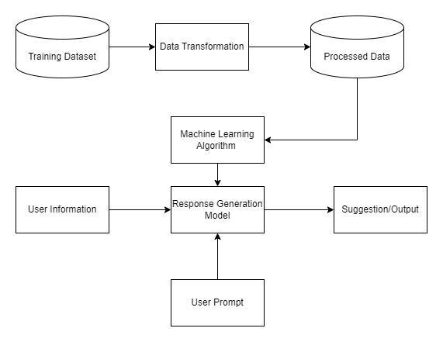

Fig 1. Block Diagram

The provided block diagram illustrates a general framework for a chatbot or conversational AI system. Here's a breakdown of each component:

**1. Training Dataset:**

* This is the foundational data used to train the machine learning model.
* It typically consists of a large collection of conversations, questions, and corresponding answers or responses.

**2. Data Transformation:**

* This component processes the raw training data to prepare it for the machine learning algorithm.
* Common transformations include:
  + Cleaning and preprocessing: Removing noise, inconsistencies, or irrelevant information.
  + Feature engineering: Creating new features or transforming existing ones to improve model performance.
  + Tokenization: Breaking text into individual words or tokens.
  + Vectorization: Converting text into numerical representations (e.g., using word embeddings).

#### 

#### 

#### 4.2 Architecture Diagram

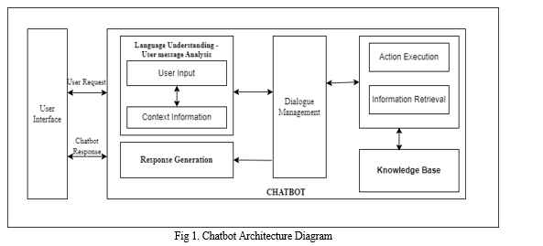

Fig 2. Architecture Diagram

This architecture diagram provides a visual representation of the WellMind Chatbot AI's components, their interactions, and the data flow within the system. The modular design enables scalability, maintainability, and the ability to easily incorporate new features or updates

#### 4.3 Design of the proposed system

#### Data Flow Diagram

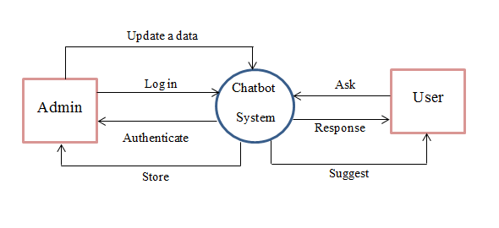

Fig 3. Dataflow Diagram

#### Flowchart Diagram

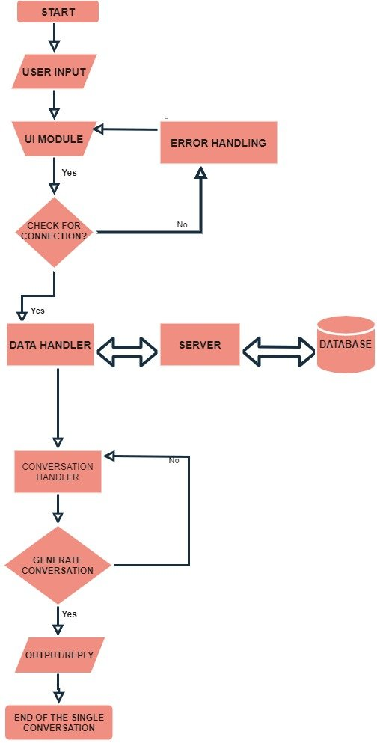

Fig 4. Flowchart Diagram

#### A visual representation of the WellMind Chatbot AI's workflow, illustrating how it processes user input, accesses relevant information, generates appropriate responses, and continuously improves its performance.

#### 

#### 4.3 Results

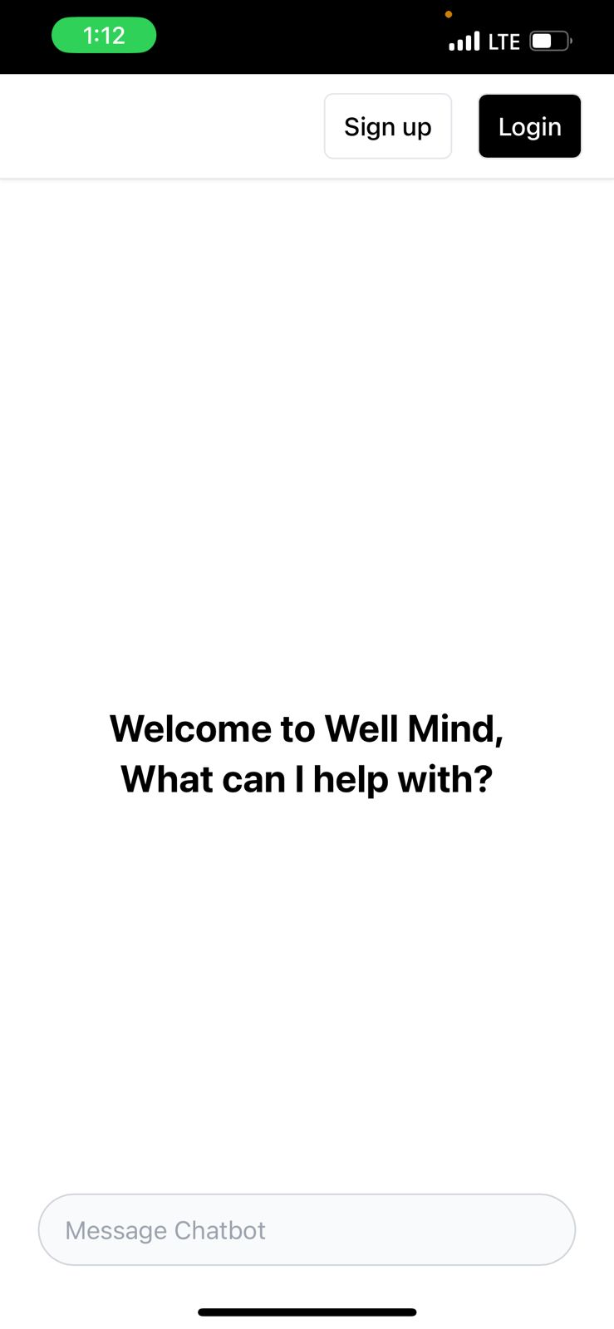

Fig 5.

In Fig.5 illustrates the Home page of the app where we text the chatbot about how it works.

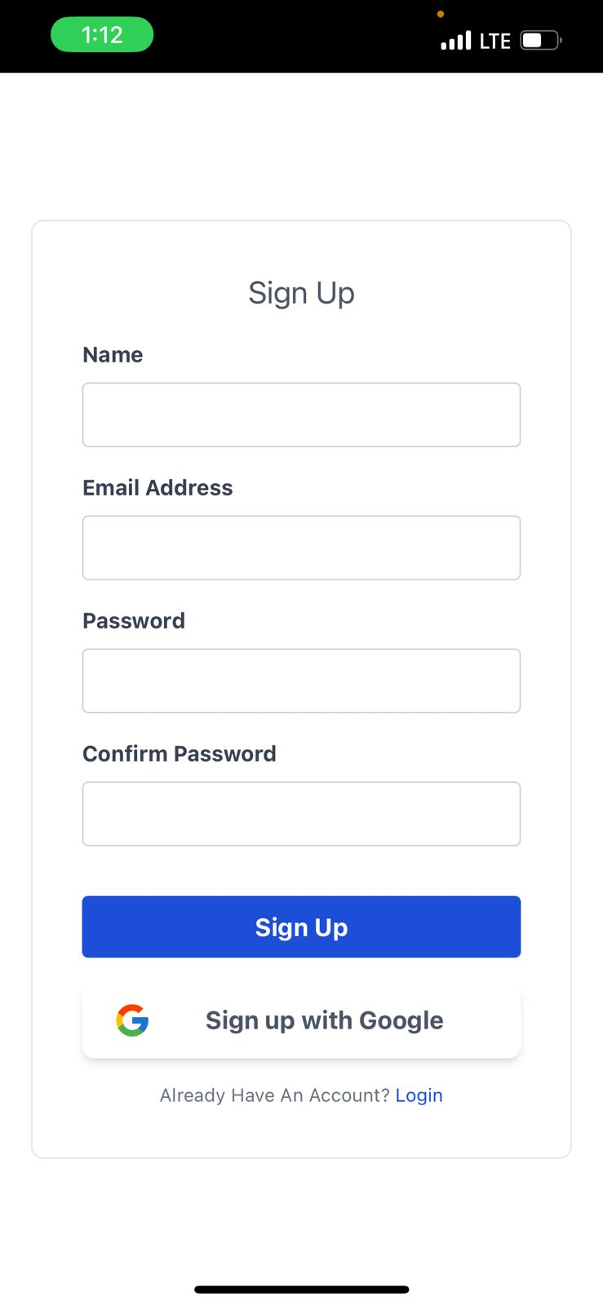

Fig 6.

Fig.6 shows the signup page of chatbot app which is also integrated with google sign up.

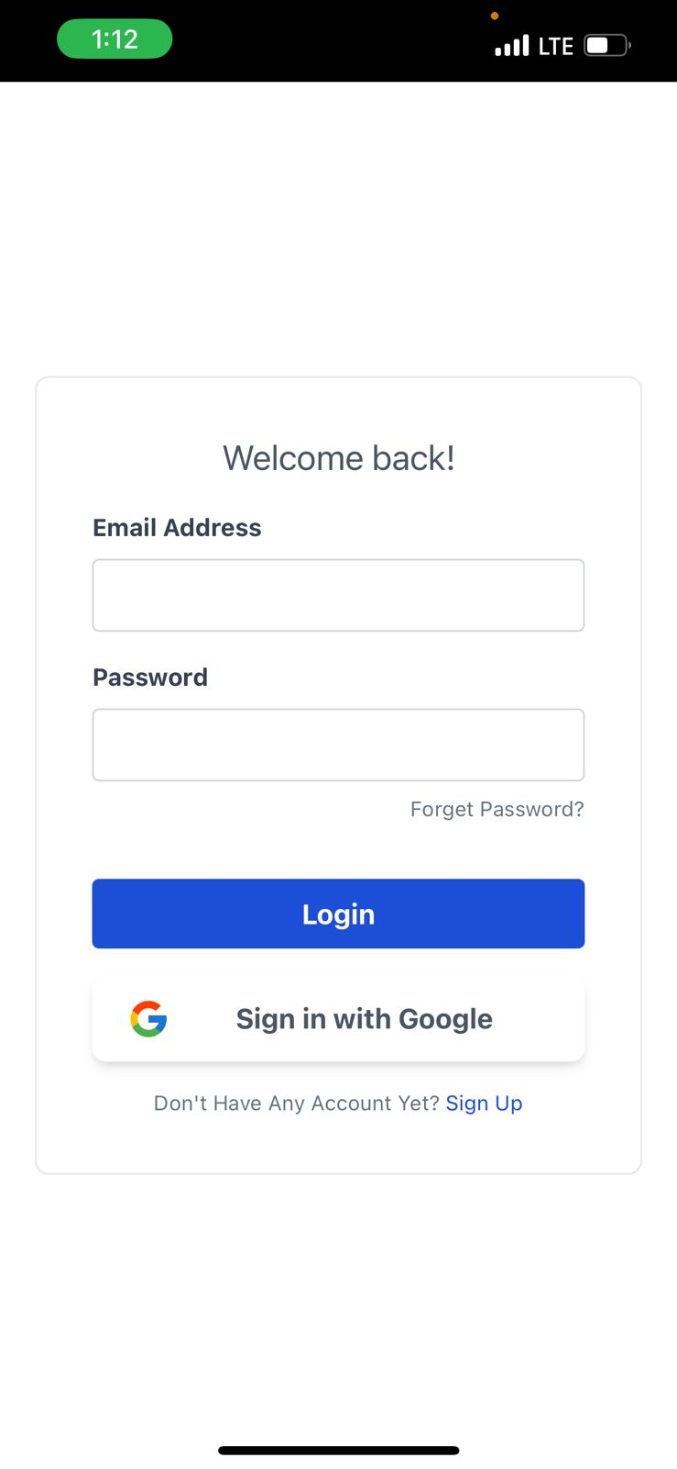

Fig .7 Login Page

Fig.7 illustrates the login page of the chatbot app which is also integrated with google platform

### 

### 

### 

### 

### 

### 

### Chapter 5: Proposed Results and Discussions

#### 5.1 Proposed Output

Text-Based Answers: Straightforward Responses:"From what you've said, it appears like you may be dealing with anxiety issues. Do you want to know more about coping mechanisms and anxiety? Responses that are instructive: "Depression is a severe mental illness. The following resources may be useful: [Resource list]" Empathic Reactions: "I recognize that you're currently feeling overburdened. Feelings like this are OK. Let's discuss some strategies for stress management.Inquiring Reactions: "Could you elaborate on your feelings? It could give me a better understanding of your circumstances. Interactive Components: Assessments or Quizzes: "To help me better understand your situation, please take this short quiz about your mood and behavior."

Crucial Points to Remember: Conciseness and Clarity: Answers should be simple to comprehend and free of technical jargon. Empathy and Support: To help users feel understood and appreciated, the chatbot should be sympathetic and helpful.Informativeness: Reactions must to offer pertinent data and sources. Interactivity: Questions, tests, and other interactive features should be used by the chatbot to keep consumers interested. Personalization: Reactions ought to be customized to each user's requirements and inclinations.

**5.2 Evaluation Parameters**

Several crucial factors can be utilized to evaluate the WellMind Chatbot AI's efficacy: User Contentment Feedback surveys: Ask users about their general impressions of the chatbot's helpfulness, responsiveness, and usability. NPS, or net promoter score, is: Analyze user loyalty and propensity to refer others to the chatbot. Engagement of Users: Monitor data like the average length of a chat, usage frequency, and user retention rate. Relevance and Accuracy of Responses Human Evaluation: Ask human specialists to assess the chatbot's answers for appropriateness, relevancy, and correctness. Classification of Intent Accuracy: Evaluate how well the chatbot can determine the user's intention. Named Recognition of Entities Accuracy: Assess how well the chatbot recognizes named entities in user input. Quality of Knowledge Bases Completeness: Verify that a variety of mental health subjects and resources are included in the knowledge base. Accuracy: Confirm that the data in the knowledge base is accurate. Current: Make sure the knowledge base is up to date with the most recent findings and investigations. Moral Aspects to Take into Account Privacy and Security: Make sure that user information is managed safely and in accordance with applicable privacy laws. prejudice & Bias: Keep an eye out for any indications of prejudice or bias in the chatbot's responses. Misinformation: Avoid having the chatbot give false or deceptive information.

### Chapter 6: Plan of Action for Next Semester

#### 6.1 Work Done Till Date

* **Data Collection**
* **Model Implementation**

#### 6.2 Plan of Action for Project II

* A more comprehensive and detailed dataset is essential for optimizing our model’s predictive capabilities.
* Transform the Figma login and signup page designs into a functional application interface.
* Literature review of more papers related to the topic for better understanding.
* Reflect the recent development in the project within the research paper.
* Integrating back end and front end
* Enhancing UI
* Betterment of dataset
* Additional Features like contacting a doctor ,emergency assistance etc.

**Chapter 7: Conclusions**

To guarantee that the system is efficient, dependable, and easy to use, a thorough assessment encompassing many metrics must be conducted on the AI-powered chatbot for mental health assistance. Through evaluation of user happiness, engagement, accuracy, and response time, we may obtain a comprehensive picture of the chatbot's effectiveness. Sentiment analysis and referral success rates will shed light on how well the chatbot can serve users in a compassionate and useful way. In order to guarantee that the chatbot keeps improving and meeting the demands of its users, the confusion matrix will assist in identifying areas for development. To sum up, the amalgamation of these assessment metrics will provide a sturdy structure for evaluating the efficacy of the artificial intelligence-driven chatbot. This method guarantees that the chatbot is truthful, sympathetic, and useful in providing supporting users' mental health.One intriguing option for offering easily accessible and encouraging mental health care is the WellMind Chatbot AI. The chatbot may assist users by using natural language processing, a thorough knowledge base, and tailored responses. Users can access information regarding mental health, including symptoms, coping mechanisms, and a variety of mental health issues. Get assistance and direction: The chatbot can offer sympathetic answers as well as advice on how to deal with stress and worry. Connect with resources: Users can be sent to organizations, helplines, and other resources that are pertinent to them. The chatbot's modular design gives it flexibility and scalability, allowing it to add new features and adjust to changing user needs. Through ongoing assessment and enhancement of its functionality, the WellMind Chatbot AI has the potential to develop into a useful instrument for advancing mental wellness.

**Chapter 8: References**

1. M. A. Salehinejad et al., "Recent Advances in Using AI for Mental Health and Well-Being," IEEE Journal of Biomedical and Health Informatics, vol. 24, no. 8, pp. 2313-2325, August 2020.
2. J. Torous, M. D. Myrick, C. Rauseo-Ricupero, "Digital Mental Health and COVID-19: Using Technology Today to Accelerate the Curve on Access and Quality Tomorrow," JMIR Mental Health, vol. 7, no. 3, 2020.
3. A. L. Christensen, "Efficacy of Mental Health Chatbots in Providing Psychological Support: A Systematic Review," 2021.
4. K. Inkster, et al., "Machine Learning and Mental Health: Applications, Challenges, and Ethical Concerns," Frontiers in Psychiatry, 2020.
5. J. Abdullah, "Chatbots as Digital Mental Health Interventions: Examining the Ethical Implications," Ethics & Information Technology, 2021.
6. B. Kumar, "Natural Language Processing in AI-Powered Mental Health Tools," ACM Transactions on Health Informatics, 2020.
7. Higgins, Oliver, et al. "Artificial intelligence (AI) and machine learning (ML) based decision support systems in mental health: An integrative review." *International Journal of Mental Health Nursing* 32.4 (2023): 966-978.
8. Minerva, Francesca, and Alberto Giubilini. "Is AI the future of mental healthcare?." *Topoi* 42.3 (2023): 809-817.
9. Tutun, Salih, et al. "An AI-based decision support system for predicting mental health disorders." *Information Systems Frontiers* 25.3 (2023): 1261-1276.
10. Hamdoun, Salah, et al. "AI-based and digital mental health apps: Balancing need and risk." *IEEE Technology and Society Magazine* 42.1 (2023): 25-36.

**Chapter 9: Appendix**

**List of Figures**

| **Number** | **Name** |
| --- | --- |
| Fig.1 | Block Diagram |
| Fig.2 | Architecture Diagram |
| Fig.3 | Data Flow Diagram |
| Fig.4 | Flow Chart |
| Fig.5 | Home page |
| Fig.6 | Sign up page |
| Fig.7 | Login page |

**List of Tables**

| **Number** | **Name** |
| --- | --- |
| Table I | Literature Survey |
| Table II | Comparison of Evaluation of Algorithms |

**REVIEW 1 EVALUATION SHEET**

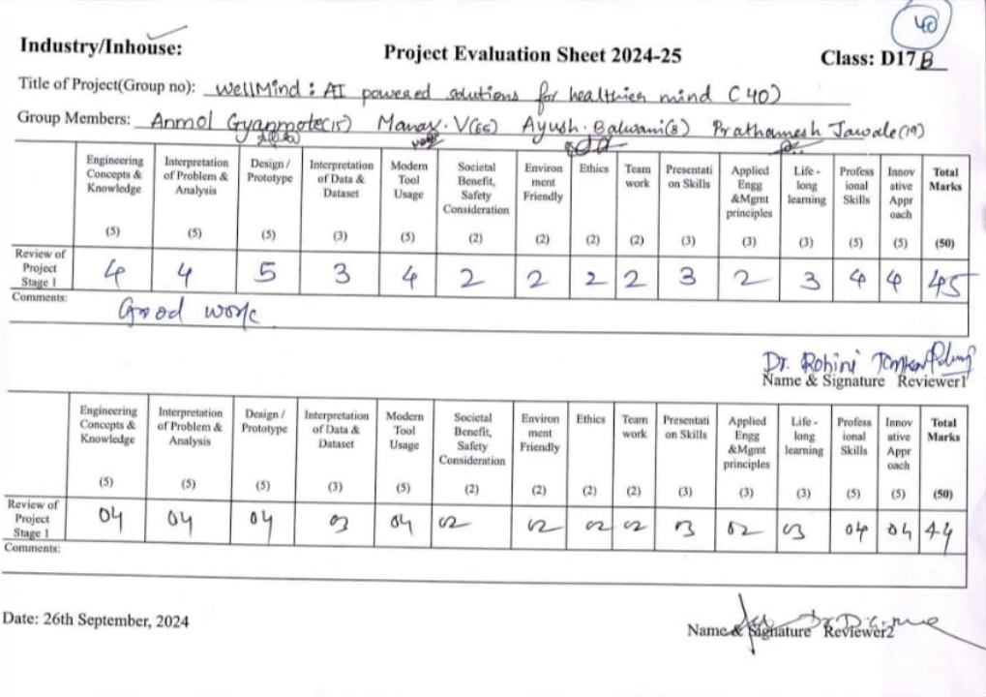

**REVIEW 2 EVALUATION SHEET**